Confidential Patient Data
IF YOU NEED ANY ASSISTANCE COMPLETING THIS FORM, PLEASE ASK THE FRONT DESK
PATIENT INFORMATION Today's Date:____________

Name:_______________________________________________ Date of Birth:__________________

Address:____________________________ City:_________________ State:________ Zip:________

Home Phone:_________________ Work Phone:________________ Cell Phone:________________
Age:_______  Male  Female
E-Mail:_________________________________
Marital Status:  Married  Single  Divorced  Separated  Other __________
Name of Spouse or Nearest Relative:_________________________ Phone:____________________
Your Occupation____________________________ Your Employer:__________________________
Referred to this Office by: Friend/Family Member - Name?__________________________
❑ Yellow Pages  Internet  Clinic Location  Other ______________

Payment for Services will be by:  Cash  Check  Credit Card  Health Insurance
❑ Automobile Insurance
Name of Insurance Co.:_____________________________ Insured's Employer:_________________ Insured's Social Security #:_____________________ Insured’s Date of Birth:__________
Are you covered by more than one insurance company?  Yes  No Name: ___________________

About Your Health – The human body is designed to be healthy. Throughout life, events occur which damage your health expression. This case history will uncover the layers of damage, especially to your nervous system, that resulted in poor health. Then following the exam, your Chiropractor will outline a course of care to begin to correct the layers of damage and recover your optimal health potential.

MEDICAL/FAMILY HISTORY S = Self M = Mother F = Father
(Please indicate which conditions have been experienced by the above by marking appropriate boxes).
S M F S M F S M F
❑   AIDS    dislocated joints    neck pain
❑   anemia    epilepsy    nervousness
❑   arthritis    German measles    numbness
❑   asthma    headaches    polio
❑   back pain    heart trouble    poor circulation
❑   bladder trouble    reproductive disorders    hepatitis
❑   bone fracture    high blood pressure    rheumatic fever
❑   cancer    HIV/ARC    rheumatism
❑   chest pain    kidney disorder    scarlet fever
❑   concussion    bowel control loss    serious injury
❑   convulsions    menstrual cramps    sinus trouble
❑   diabetes    multiple sclerosis    tuberculosis
❑   indigestion    muscular dystrophy    venereal disease
Have you been treated by a physician for any health condition in the last year?  Yes  No

Describe Condition________________________________________________ Date of Last Physical Exam____________
Vitals: Height __________ Weight __________ Blood Pressure__________ Are you running a fever?________________

TRAUMA HISTORY: (include birth/childhood)
1.____________________________________________________________________________ Date:________________
2.____________________________________________________________________________ Date:________________
3.____________________________________________________________________________ Date:________________

SURGICAL HISTORY:
1.____________________________________________________________________________ Date:________________
2.____________________________________________________________________________ Date:________________
3.____________________________________________________________________________ Date:________________

PLEASE DESCRIBE PRESENT SYMPTOMS AND ILL HEALTH:
Please rate your symptoms (1-10, with 1 being least serious)
1.__________________________________________________________________________________ __________
2.__________________________________________________________________________________ __________
3.__________________________________________________________________________________ __________
4.__________________________________________________________________________________ __________

SYMPTOMS ARE WORSE IN  MORNING  AFTERNOON  NIGHT

WHEN AND HOW OCCURRED?________________________________________________________________________
___________________________________________________________________________________________________

SYMPTOMS DEVELOPED FROM:  JOB RELATED INJURY  AUTO ACCIDENT  OTHER ACCIDENT
❑ ILLNESS  UNKNOWN CAUSE  GRADUAL ONSET DATE OCCURRED:____________________

SYMPTOMS HAVE PERSISTED FOR # ____HOUR(S) ____DAY(S) __WEEK(S) ___MONTH(S) ___YEAR(S)
SYMPTOMS/COMPLAINTS:  COME & GO  ARE CONSTANT

HAVE YOU EVER HAD THIS BEFORE:  NO  YES WHEN?________________________________________

IF YOU WERE TO GUESS, WHAT DO YOU THINK IS CAUSING YOUR COMPLAINTS?
___________________________________________________________________________________________________

NAME AND LOCATION OF DOCTORS PREVIOUSLY SEEN FOR PRESENT CONDITION(S):
___________________________________________________________________________________________________

ARE YOU TAKING ANY VITAMINS  NO  YES WHAT KIND?____________________________________
ARE YOU TAKING ANY MEDICATIONS  NO  YES (SEE ADDITIONAL PATIENT INFORMATION FORM)
ARE YOU PREGNANT  NO  YES DATE OF LAST MENSTRUAL PERIOD____________

PLEASE CHECK THE FOLLOWING ACTIVITIES THAT AGGRAVATE YOUR CONDITION:
❑ BENDING  REACHING  STRAINING AT STOOL  COUGHING  SITTING  TURNING HEAD
❑ LIFTING  SNEEZING  WALKING  LYING DOWN  STANDING

PLEASE CHECK THE FOLLOWING ACTIVITIES THAT RELIEVE YOUR CONDITION:
❑ BENDING  SITTING  LIFTING  STANDING  LYING DOWN  TURNING HEAD  REACHING
❑ WALKING

PLEASE CHECK ANY ADDITIONAL SYMPTOMS YOU MAY BE EXPERIENCING:
❑ blurred vision  buzzing in ears  cold feet  cold hands  cold sweats  concentration loss/confusion
❑ constipation  depression /weeping spells  diarrhea  dizziness  face flushed  fainting  fatigue  fever
❑ headaches  insomnia  light bothers eyes  loss of balance  loss of smell  loss of taste
❑ low resistance to colds  muscle jerking  numbness in fingers  numbness in toes  pins and needles in arms
❑ pins and needles in legs  ringing in ears  shortness of breath  stiff neck  stomach upset

About Your Care – Chiropractic provides three types of care. The first Initial Intensive Care which corrects the most recent layer of Spinal and Neurological damage. This care usually reduces or eliminates the symptoms. Then begins Restorative Care which corrects the years of damage that occur when there were few symptoms. And finally Chiropractic offers a genuine approach to Wellness Care. All of these options will be explained at your report of findings. Then you’ll be able to begin a course of care that fits your health goals.

Patient's Signature:___________________________________
Additional Patient Information Form: Today's Date:____________

Name:_______________________________________________

Are you currently taking any medications? (Please circle one) Yes No

If yes, please list

______________________ _____________________ ______________________

______________________ _____________________ ______________________

______________________ _____________________ ______________________

Are you allergic to any medications? (Please circle one) Yes No

If yes, please list

______________________ _____________________ ______________________

______________________ _____________________ ______________________

What is your race? (Please circle one)

White Black or African American Asian American Indian or Alaska Native

Native Hawaiian or Other Pacific Islander Other Race More Than One Race

What is your ethnicity? (Please circle one)

Hispanic or Latino Not Hispanic or Latino

What is your preferred language?

English Spanish French German Italian Russian

Portuguese Chinese Japanese Korean Vietnamese

What is your smoking status? (Please circle one)

Current Every Day Smoker Current Some Day Smoker Former Smoker Never Smoker

What is your preferred method of communication for private health data? (Please circle one)

Home Phone Work Phone Mobile Phone e-Mail Standard Mail

Discomfort Diagram

Instructions

On the following diagram, indicate all areas of:

Pain - XXXX
Stiffness - / / / /
Numbness - OOOO
Other - ______
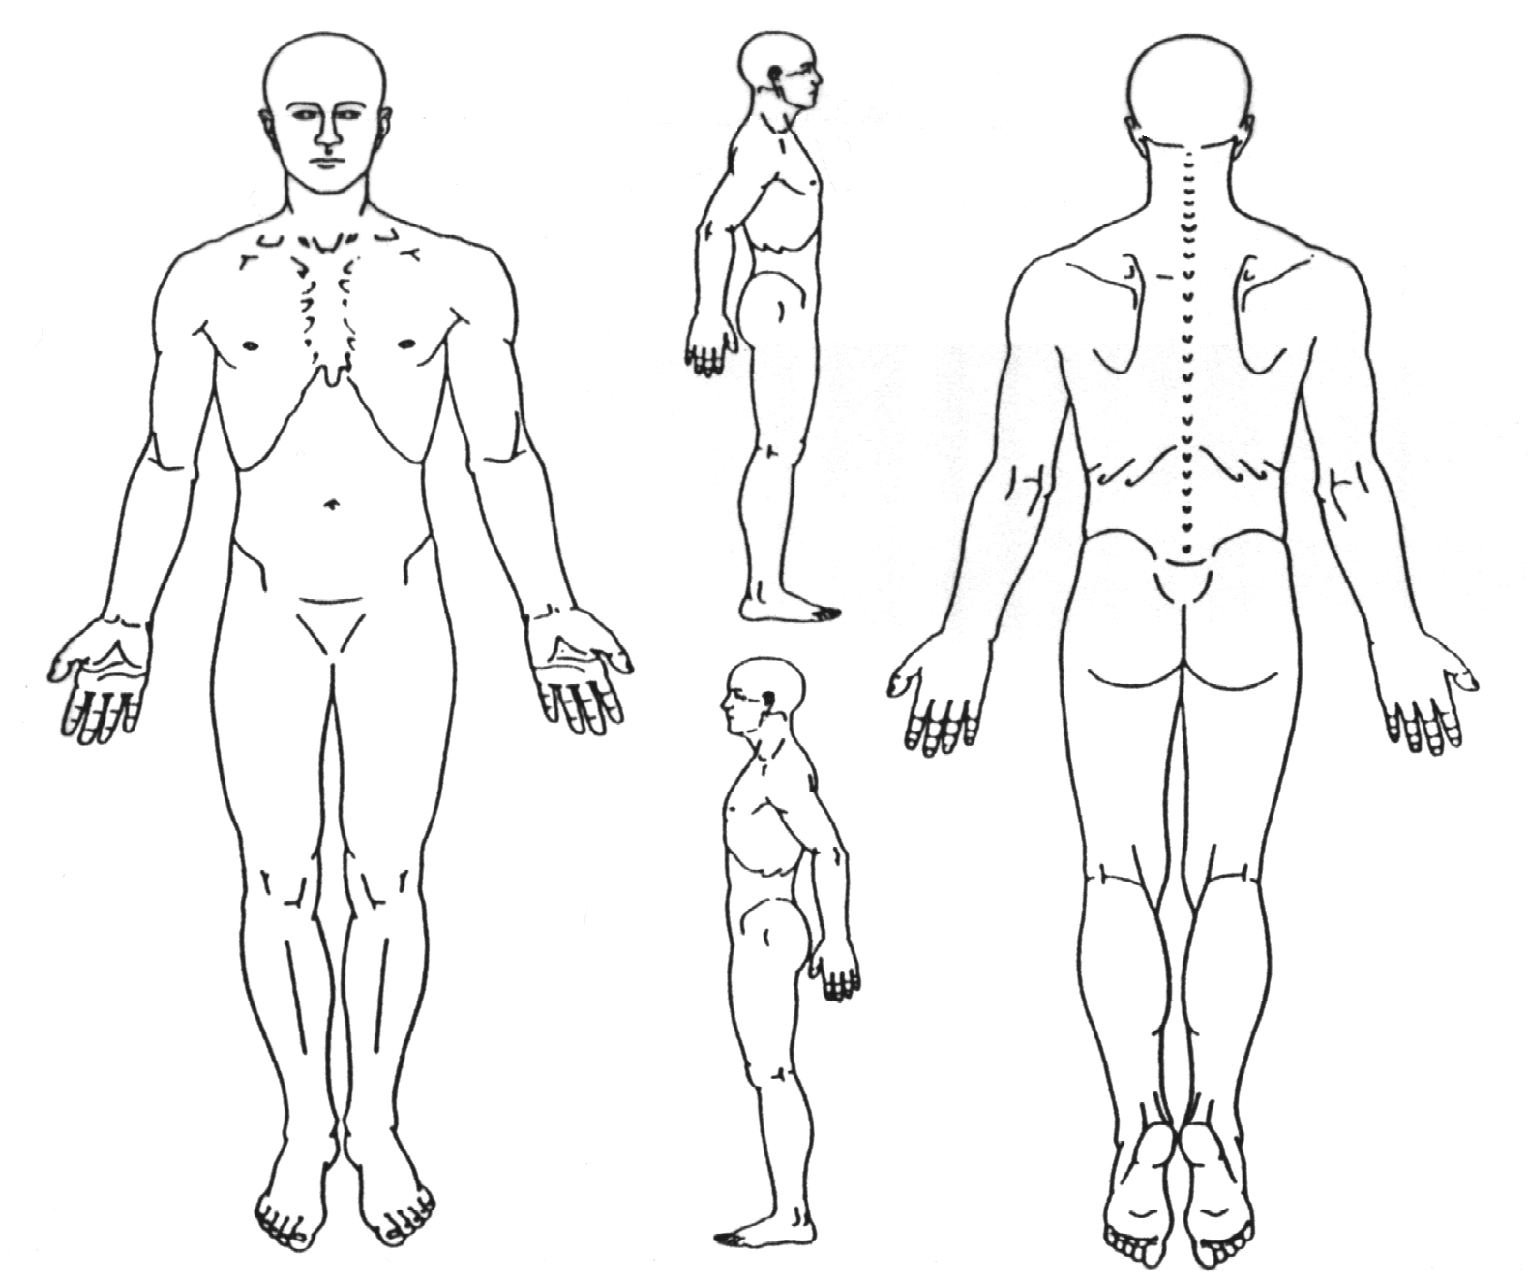(specify)

AUTHORIZATION AND ASSIGNMENT

I understand that I am personally responsible for the payment of services rendered to me by Essential Family Chiropractic. In the event that I have insurance, I hereby assign the benefits that I am eligible to receive for the care rendered in this office to this office.

I authorize Essential Family Chiropractic and Staff to release any information to any insurance company, adjuster, or attorney that will assist in the payment of the claim. I fully understand and agree that the insurance policies are in agreement between the insurance carrier and myself. Any balance due after insurance payment will be promptly paid by me. If I am uninsured, or choose not to use my insurance, I will be wholly responsible for the bill.

I hereby authorize my insurance company to remit payment directly to:

Essential Family Chiropractic
7270 Cradlerock Way, Suite 001
Columbia, MD 21045

For Medicare: I authorize any holder of medical information about me to release to the Health Care Financing Administration and its agents any information needed to determine that benefits to the benefits to be made to Essential Family Chiropractic on my behalf. I further give my permission for evaluation and treatment by Essential Family Chiropractic.

It is further understood that the statute of limitations is three (3) years from the time said services were last performed. I further understand that because of long delays in the trial docket, many cases are not tried or settled until a date which is beyond the three (3) years after the last services was performed. In view of this, I hereby agree that the statute of limitations with respect to any claim for services mentioned above will not begin to run until there is a denial in writing by me of the balance claimed to be due to you by me.

In the event there is a breech of this agreement, I understand that I will be responsible for any expenses relating to the collection of my account including but not limited to services and administration charges, legal fees.

I here by state and agree that a photocopy of this document will be deemed valid and binding on all parties as the original. This is a direct assignment of my rights and benefits under this policy.

___________________________________ _________________________________________
Date Signature (Parent or Guardian if a Minor)

___________________________________ _________________________________________
Witness Policy Holder

Essential Family Chiropractic
Terms of Acceptance

When a practice member seeks chiropractic health care and we accept a practice member for such care, it is essential for both to be working towards the same objective.

Chiropractic has only one goal. It is important that each practice member understand both the objective and the method that will be used to attain it. This will prevent any confusion or disappointment.

Adjustment: An adjustment is the specific application of forces to facilitate the body's correction of vertebral subluxation. Our chiropractic method of correction is by specific adjustments of the spine.

Health: A state of optimal physical, mental and social well-being, not merely the absence of infirmity.

Vertebral Subluxation: A misalignment of one or more of the 24 vertebra in the spinal column which causes alteration of nerve function and interference to the transmission of mental impulses, resulting in a lessening of the body's innate ability to express its maximum health potential.

We do not offer to diagnose or treat any disease or condition other than vertebral subluxation. However, if during the course of a chiropractic spinal examination, we encounter non-chiropractic or unusual findings, we will advise you. If you desire advice, diagnosis or treatment for those findings, we will recommend that you seek the services of a health care provider who specializes in that area.

Regardless of what the disease is called, we do not offer to treat it. Nor do we offer advice regarding treatment prescribed by others. OUR ONLY PRACTICE OBJECTIVE is to eliminate a major interference to the expression of the body's innate wisdom. Our only method is specific adjusting to correct vertebral subluxations.

I,____________________________ have read and fully understand the above statements.
(print name)

All questions regarding the doctor's objectives pertaining to my care in this office have been answered to my complete satisfaction.

I therefore accept chiropractic care on this basis.

___________________________________________________________________________
(signature) (date)

========================================================================================
Consent to evaluate and adjust a minor child

I,________________________being the parent or legal guardian of ___________________________have read and fully understand the above terms of acceptance and hereby grant permission for my child to receive chiropractic care.

❑ Check here if you wish to give consent for the minor to receive chiropractic care without an accompanying adult.
This consent shall be in effect for:  Date___________________ (only)
❑ Indefinitely, until revoked by written communication

========================================================================================
Pregnancy Release

This is to certify that to the best of my knowledge I am not pregnant and the above doctor and his/her associates have my permission to perform an x-ray evaluation. I have been advised that x-ray can be hazardous to an unborn child. Date of last menstrual period:

___________________________________________________________________________
(signature) (date)

Notice of Privacy Practices
THIS NOTICE DESCRIBES HOW MEDICAL INFORMATION ABOUT YOU
MAY BE USED AND DISCLOSED AND HOW YOU CAN GET ACCESS TO
THAT INFORMATION. PLEASE REVIEW THIS NOTICE CAREFULLY.

The Practice (the “Practice”), in accordance with the federal Privacy Rule, 45 CFR parts 160 and 164 (the “Privacy Rule”) and applicable state law, is committed to maintaining the privacy of your protected health information (“PHI”). PHI includes information about your health condition and the care and treatment you receive from the Practice and is often referred to as your health care or medical record. This Notice explains how your PHI may be used and disclosed to third parties. This Notice also details your rights regarding your PHI.

How the Practice May Use and
Disclose Your Protected Health Information

The Practice, in accordance with this Notice and without asking for your express consent or authorization, may use and disclose your PHI for the purposes of:

Treatment – To provide you with the health care you require, the Practice may use and disclose your PHI to those health care professionals, whether on the Practice’s staff or not, so that it may provide, coordinate, plan and manage your health care. For example, a chiropractor treating you for lower back pain may need to know and obtain the results of your latest physician examination or last treatment plan.

Payment – To get paid for services provided to you, the Practice may provide your PHI, directly or through a billing service, to a third party who may be responsible for your care, including insurance companies and health plans. If necessary, the Practice may use your PHI in other collection efforts with respect to all persons who may be liable to the Practice for bills related to your care. For example, the Practice may need to provide the Medicare program with information about health care services that you received from the Practice so that the Practice can be reimbursed. The Practice may also need to tell your insurance plan about treatment you are going to receive so that it can determine whether or not it will cover the treatment expense.

Health Care Operations – To operate in accordance with applicable law and insurance requirements, and to provide quality and efficient care, the Practice may need to compile, use and disclose your PHI. For example, the Practice may use your PHI to evaluate the performance of the Practice’s personnel in providing care to you.

Other EXAMPLES OF HOW the Practice May Use Your

Protected Health Information
Advice of Appointment and Services – The Practice may, from time to time, contact you to provide appointment reminders or information about treatment alternatives or other health-related benefits and services that may be of interest to you. The following appointment reminders may be used by the Practice: a) a postcard mailed to you at the address provided by you; and b) telephoning your home and leaving a message on your answering machine or with the individual answering the phone.

Directory/Sign-In Log – The Practice maintains a sign-in log at its reception desk for individuals seeking care and treatment in the office. The sign-in log is located in a position where staff can readily see who is seeking care in the office, as well as the individual’s location within the Practice’s office suite. This information may be seen by, and is accessible to, others who are seeking care or services in the Practice’s offices.

Family/Friends – The Practice may disclose to a family member, other relative, a close personal friend, or any other person identified by you, your PHI directly relevant to such person’s involvement with your care or the payment for your care. The Practice may also use or disclose your PHI to notify or assist in the notification (including identifying or locating) a family member, a personal representative, or another person responsible for your care, of your location, general condition or death. However, in both cases, the following conditions will apply:

reasonably infer from If you are present at or prior to the use or disclosure of your PHI, the Practice may use or disclose your PHI if you agree, or if the Practice can the circumstances, based on the exercise of its professional judgment, that you do not object to the use or disclosure.

If you are not present, the Practice will, in the exercise of professional judgment, determine whether the use or disclosure is in your best interests and, if so, disclose only the PHI that is directly relevant to the person’s involvement with your care.

Other Use & Disclosures WHICH MAY
BE PERMITTED OR REQUIRED BY LAW

The Practice may also use and disclose your PHI without your consent or authorization in the following instances:

De-identified Information – The Practice may use and disclose health information that may be related to your care but does not identify you and cannot be used to identify you.

Business Associate – The Practice may use and disclose PHI to one or more of its business associates if the Practice obtains satisfactory written assurance, in accordance with applicable law, that the business associate will appropriately safeguard your PHI. A business associate is an entity that assists the Practice in undertaking some essential function, such as a billing company that assists the office in submitting claims for payment to insurance companies.

Personal Representative – The Practice may use and disclose PHI to a person who, under applicable law, has the authority to represent you in making decisions related to your health care.

Emergency Situations – The Practice may use and disclose PHI for the purpose of obtaining or rendering emergency treatment to you provided that the Practice attempts to obtain your Consent as soon as possible: The Practice may also use and disclose PHI to a public or private entity authorized by law or by its charter to assist in disaster relief efforts, for the purpose of coordinating your care with such entities in an emergency situation.

Public Health Activities – The Practice may use and disclose PHI when required by law to provide information to a public health authority to prevent or control disease.

Abuse, Neglect or Domestic Violence – The Practice may use and disclose PHI when authorized by law to provide information if it believes that the disclosure is necessary to prevent serious harm.

Health Oversight Activities – The Practice may use and disclose PHI when required by law to provide information in criminal investigations, disciplinary actions, or other activities relating to the community’s health care system.

Judicial and Administrative Proceeding – The Practice may use and disclose PHI in response to a court order or a lawfully issued subpoena.

Law Enforcement Purposes – The Practice may use and disclose PHI, when authorized, to a law enforcement official. For example, your PHI may be the subject of a grand jury subpoena, or if the Practice believes that your death was the result of criminal conduct.

Coroner or Medical Examiner – The Practice may use and disclose PHI to a coroner or medical examiner for the purpose of identifying you or determining your cause of death.

Organ, Eye or Tissue Donation – The Practice may use and disclose PHI if you are an organ donor to the entity to whom you have agreed to donate your organs.

Research – The Practice may use and disclose PHI subject to applicable legal requirements if the Practice is involved in research activities.

Avert a Threat to Health or Safety – The Practice may use and disclose PHI if it believes that such disclosure is necessary to prevent or lessen a serious and imminent threat to the health or safety of a person or the public and the disclosure is to an individual who is reasonably able to prevent or lessen the threat.

Specialized Government Functions – The Practice may use and disclose PHI when authorized by law with regard to certain military and veteran activity.

Workers’ Compensation – The Practice may use and disclose PHI if you are involved in a Workers’ Compensation claim to an individual or entity that is part of the Workers’ Compensation system.

National Security and Intelligence Activities – The Practice may use and disclose PHI to authorized governmental officials with necessary intelligence information for national security activities.

Military and Veterans – The Practice may use and disclose PHI if you are a member of the armed forces, as required by the military command authorities.

Authorization
Uses and/or disclosures, other than those described above, will be made only with your written Authorization.
Your Rights

You have the right to:

Revoke any Authorization or consent you have given to the Practice, at any time. To request a revocation, you must submit a written request to the Practice’s Privacy Officer.

Request special restrictions on certain uses and disclosures of your PHI as authorized by law. In general, this relates to your right to request special restrictions concerning disclosures of your PHI regarding uses for treatment, payment and operational purposes under Privacy Rule, Section 164.522(a) and restrictions related to disclosures to your family and other individuals involved in your care under Privacy Rule, Section 164.510(b). Except in certain instances, the Practice may not be obligated to agree to any requested restrictions. To request restrictions, you must submit a written request to the Practice’s Privacy Officer. In your written request, you must inform the Practice of what information you want to limit, whether you want to limit the Practice’s use or disclosure, or both, and to whom you want the limits to apply. If the Practice agrees to your request, the Practice will comply with your request unless the information is needed in order to provide you with emergency treatment.

Receive confidential communications or PHI by alternative means or at alternative locations as provided by Privacy Rule Section 164.522(b). For instance, you may request all written communications to you marked “Confidential Protected Health Information.” You must make your request in writing to the Practice’s Privacy Officer. The Practice will accommodate all reasonable requests.

Inspect and copy your PHI as provided by federal law (including Privacy Rule, Section 164.524) and state law. To inspect and copy your PHI, you must submit a written request to the Practice’s Privacy Officer. The Practice can charge you a fee for the cost of copying, mailing or other supplies associated with your request. In certain situations that are defined by law, the Practice may deny your request, but you will have the right to have the denial reviewed as set forth more fully in the written denial notice.

Amend your PHI as provided by federal law (including Privacy Rule, Section 164.526) and state law. To request an amendment, you must submit a written request to the Practice’s Privacy Officer. You must provide a reason that supports your request. The Practice may deny your request if it is not in writing, if you do not provide a reason in support of your request, if the information to be amended was not created by the Practice (unless the individual or entity that created the information is no longer available), if the information is not part of your PHI maintained by the Practice, if the information is not part of the information you would be permitted to inspect and copy, and/or if the information is accurate and complete. If you disagree with the Practice’s denial, you will have the right to submit a written statement of disagreement.

Receive an accounting of disclosures of your PHI as provided by federal law (including Privacy Rule Section 164.528) and state law. To request an accounting, you must submit a written request to the Practice’s Privacy Officer. The request must state a time period, which may not be longer than six (6) years and may not include dates before April 14, 2003. The request should indicate in what form you want the list (such as a paper or electronic copy). The first list you request within a twelve (12) month period will be free, but the Practice may charge you for the cost of providing additional lists. The Practice will notify you of the costs involved and you can decide to withdraw or modify your request before any costs are incurred.

Receive a paper copy of this Privacy Notice from the Practice (as provided by Privacy Rule Section 164.520(b)(1)(iv)(F)) upon request to the Practice’s Privacy Officer.

Complain to the Practice or to the Secretary of HHS (as provided by Privacy Rule Section 164.520(b)(1)(vi)) if you believe your privacy rights have been violated. To file a complaint with the Practice, you must contact the Practice’s Privacy Officer. All complaints must be in writing.

To obtain more information about your privacy rights or if you have questions you want answered about your privacy rights (as provided by Privacy Rule Section 164.520(b)(2)(vii)), you may contact the Practice’s Privacy Officer as follows:

Practice’s Requirements

The Practice:

Is required by federal law to maintain the privacy of your PHI and to provide you with this Privacy Notice detailing the Practice’s legal duties and privacy practices with respect to your PHI.

Under the Privacy Rule, may be required by State law to grant greater access or maintain greater restrictions on the use or release of your PHI than that which is provided for under federal law.

Is required to abide by the terms of this Privacy Notice.

Reserves the right to change the terms of this Privacy Notice and to make the new Privacy Notice provisions effective for all of your PHI that it maintains.

Will distribute any revised Privacy Notice to you prior to implementation.

Will not retaliate against you for filing a complaint.

Effective Date

This Notice is in effect as of 04/15/03.

Patient Acknowledgement

By subscribing my name below, I acknowledge receipt of a copy of this Notice, and my understanding and my agreement to its terms.

_____________________________
Patient Signature
Date:_______________

